Corporate Credit Risk Assessment Using Financial Statement Data

Student ID: 100777866
100777866@unimail.derby.ac.uk

Dissertation submitted to the University of Derby in partial fulfilment of the requirements for the award of Master of Science in Big Data Analytics

7CS997 Independent Scholarship SPR-2026

Abstract.
Corporate credit risk assessment remains one of the most critical challenges in the modern financial landscape, serving as a fundamental pillar for decision-making in lending, investment evaluation, and the management of systemic financial stability. Over the past several decades, the methodologies employed for bankruptcy prediction have undergone a profound evolution, transitioning from traditional linear statistical models to advanced machine learning techniques capturing complex, non-linear relationships.
This study details the design and implementation of a hybrid corporate credit risk assessment system that bridges the gap between these two eras. The framework integrates classical financial ratio analysis with an interactive Streamlit dashboard and advanced predictive modeling using Logistic Regression, Random Forest, and XGBoost architectures. By evaluating firms through the lens of key financial indicators, specifically profitability, leverage, and operational performance, the system generates automated risk classifications.
A significant methodological focus of this research was mitigating "data leakage" by training machine learning models on raw financial metrics rather than pre-calculated ratios, thereby ensuring independent pattern recognition. The results demonstrate that while traditional ratios remain potent indicators of risk, ensemble machine learning methods significantly enhance predictive accuracy, achieving an 84.6% success rate in test scenarios. The study also addresses the "black-box" nature of AI by incorporating Explainable AI (XAI) features and Feature Importance analysis, providing transparent justifications for risk scores. Ultimately, this research contributes a robust, interpretable framework that harmonizes historical financial wisdom with contemporary data science, providing a scalable tool for modern credit risk analytics.
Keywords: Corporate Credit Risk, Financial Distress Prediction, Machine Learning, Streamlit Dashboard, Explainable AI (XAI), Altman Z-score, XGBoost, Feature Engineering, Financial Ratio Analysis, Decision Support Systems.
Contents

Introduction 3
1 Theoretical Background and Evolution of Corporate Credit Risk Assessment 4
1.1 The Imperative of Credit Risk Modeling 4
1.2 The Foundations: Univariate Analysis and Accounting Data 5
1.3 The Multivariate Revolution and the Altman Z-Score 5
1.4 The Shift to Probabilistic Modeling and Logistic Regression 6
1.5 Structural, Market-Based, and Dynamic Approaches 6
1.6 The Impact of Machine Learning and Artificial Intelligence 7
1.7 Explainability, Feature Engineering, and Modern Synthesis 7
2 Methodology 8
2.1 Research Design and Systematic Quantitative Framework 8
2.2 Data Collection, Structure, and Preprocessing Protocols 9
2.3 Financial Feature Engineering: The Three Pillars of Risk 9
2.4 Temporal Aggregation and the Long-Term Behavioral Filter 10
2.5 Development of the Rule-Based Risk Scoring Engine 11
2.6 Interactive System Architecture and Streamlit Implementation 11
3 Results and Discussion 11
3.1 Portfolio-Wide Financial Distributions and Descriptive Analysis 12
3.2 Risk Classification Outcomes and Category Distribution 12
3.3 Separability of Financial Features and Model Accuracy 12
3.4 Temporal Trends and the "Falling Angel" Phenomenon 19
3.5 Interpretability and the Value of AI Explanation (XAI) 19
3.6 Comparative Analysis: Classical Theory vs. Computational Output 20
4 System Design and Streamlit Implementation 21
4.1 Architectural Overview 21
4.2 Operational Deployment Workflow 21
4.3 Functional Modules and Explainable AI (XAI) 22
4.4 Feature Importance Analysis 26
4.5 Technical Implementation of the Scoring Logic 27
5 Limitations and Future Work 28
5.1 The Deterministic Nature of Rule-Based Labeling 28
5.2 Challenges of Proxy-Based Classification vs. Real Default Labels 28
5.3 Macro-Financial Linkages and Systemic Risk 28
5.4 Data Integrity and the "Survivorship Bias" Problem 29
5.5 Transitioning to Probabilistic Modeling and Basel Compliance 29
5.6 Advanced Explainability (XAI) and Ethical Accountability 29
6 Conclusion 30
6.1 Synthesis of Research and Core Findings 30
6.2 Strategic Implications for Financial Decision-Making 30
6.3 Final Reflections and the Future of Credit Risk Analytics 31
References 31

Introduction

The modern financial ecosystem is characterized by an unprecedented level of complexity and volatility, making the accurate assessment of corporate credit risk a prerequisite for financial stability. This research project is designed to address the critical challenge of identifying potential financial distress in corporate entities by synthesizing classical financial theories with modern computational tools. The primary objective is to demonstrate how established accounting indicators, which have been the bedrock of risk analysis for decades, can be effectively operationalized within a digital, interactive environment using the Python programming language and the Streamlit framework. By doing so, this study aims to provide a bridge between the static analysis of the past and the dynamic, data-driven decision-making processes required in today’s banking and investment sectors.
The significance of this study is rooted in the fact that credit risk is not merely a microeconomic concern for individual lenders but a systemic issue that can affect entire markets. As highlighted by Thomas, Edelman, and Crook (Thomas, L.C., Edelman, D.B. and Crook, J.N., 2022), the failure to accurately price and predict risk was a primary catalyst for historical financial crises. Consequently, this work explores the evolution of predictive modeling, starting from the univariate approaches of Beaver (Beaver, W.H., 1966) to the multivariate dominance of Altman’s (Altman, E.I., 1968) Z-score and the probabilistic innovations of Ohlson (Ohlson, J.A., 1980). By grounding the current system in these foundational theories, the research ensures that the computational logic remains financially sound and professionally defensible.
The structure of this report is organized systematically to guide the reader through the theoretical, methodological, and empirical phases of the project. Following this introduction, the second chapter provides an exhaustive review of the existing literature, tracing the transition from early statistical failure models to the contemporary application of machine learning and explainable artificial intelligence (XAI). This section establishes the intellectual framework for the study, citing key advancements in algorithmic complexity and the increasing importance of model interpretability in a regulatory context (Lundberg, S.M. and Lee, S.I., 2017).
The third chapter details the comprehensive methodology employed to build the credit risk assessment system. This section provides a detailed explanation of the data collection process, the logic behind the feature engineering of key financial ratios, such as Return on Assets (ROA) and Debt-to-Equity, and the mathematical formulation of the scoring engine. It describes how multi-year financial data from 2022 to 2025 is cleaned, aggregated, and transformed into standardized company-level risk profiles.
The fourth chapter focuses on system design and Streamlit implementation. This section describes the technical architecture of the interactive dashboard, the operational workflow for real-time data ingestion, and the development of the user interface. Attention is given to the integration of visual analytics and the "AI Risk Assistant" module, which facilitates user engagement with complex financial datasets through transparent, logic-based justifications.
In the fifth chapter, the experimental results and empirical performance of the system are analyzed and discusse`d in detail. This part of the report utilizes visual evidence, including portfolio-wide distribution charts and comparative model accuracy metrics, to demonstrate the system's efficacy in risk segmentation. The discussion evaluates the performance of different machine learning algorithms and reflects on the transparency of the AI-generated explanations compared to traditional benchmarks.
Finally, the report concludes with a critical evaluation of the study’s limitations and a vision for future work. This final section acknowledges the challenges of deterministic modeling and the absence of real-world default labels, while outlining how the integration of supervised machine learning and macroeconomic variables could enhance the system's predictive validity. By the end of this document, the reader will have a clear understanding of how traditional financial wisdom can be empowered by modern technology to create a robust, interpretable, and actionable framework for corporate credit risk assessment.

- Theoretical Background and Evolution of Corporate Credit Risk Assessment
  - The Imperative of Credit Risk Modeling

The assessment of corporate credit risk has remained a central theme in financial economics for over half a century. At its core, the discipline focuses on the rigorous evaluation of the probability that a corporate entity will default on its financial obligations. This task is of paramount importance for a diverse range of stakeholders, including financial institutions, institutional investors, and global regulators. As noted by Thomas, Edelman, and Crook (Thomas, L.C., Edelman, D.B. and Crook, J.N., 2022), the consequences of inaccurate risk estimation are severe, often leading to significant financial losses and contributing to broader economic instability.
The history of this field is marked by a shift from subjective, qualitative assessments to objective, quantitative models. Early academic inquiries established that financial statement data, particularly financial ratios, contain high-density predictive signals regarding a firm's potential for distress (Beaver, W.H., 1966) (Altman, E.I., 1968). In the modern era, the scope of credit risk modeling has expanded exponentially, transitioning from simple statistical benchmarks to highly sophisticated machine learning algorithms (Lessmann, S. et al., 2015) (Ding, Y., 2014). This rapid evolution has been catalyzed by three primary drivers: the massive increase in the availability of granular financial data, the exponential growth in computational processing power, and the development of refined modeling techniques. This study honors this progression by synthesizing traditional ratio analysis with modern computational libraries in Python, such as those discussed by McKinney (McKinney, W., 2010) and Pedregosa et al. (Pedregosa, F. et al., 2011).

  - The Foundations: Univariate Analysis and Accounting Data

The genesis of systematic financial distress prediction can be traced back to the pioneering work of William Beaver in 1966. Beaver introduced a univariate analysis approach, which was revolutionary for its time as it demonstrated that individual financial ratios could effectively distinguish between failed and healthy firms several years prior to an actual bankruptcy filing. His research identified that specific indicators, most notably the ratio of cash flow to total debt and net income to total assets, were statistically significant predictors of a firm's long-term viability (Beaver, W.H., 1966).
This work was instrumental in establishing the enduring importance of accounting data in risk assessment. However, the univariate approach was not without flaws. Its primary limitation was its inherent simplicity, treating financial ratios as isolated variables rather than as interconnected components of a complex system. Because financial distress is a multidimensional phenomenon, an analysis that examines ratios independently often fails to capture the full picture of a firm’s health. As argued by Zmijewski (Zmijewski, M.E. , 1984) examining financial metrics in a vacuum can lead to fragmented or contradictory conclusions, necessitating the development of more holistic, multivariate frameworks.

  - The Multivariate Revolution and the Altman Z-Score

The field of credit risk assessment reached a major milestone in 1968 with the introduction of the Z-score model by Edward Altman (Altman, E.I., 1968). Utilizing Multiple Discriminant Analysis (MDA), Altman moved the industry away from univariate checks and toward a model that combined several financial ratios into a single, comprehensive score. This approach significantly improved the predictive accuracy of distress models by providing a weighted view of a firm’s liquidity, profitability, leverage, solvency, and efficiency.
The Z-score model was quickly adopted as a global standard due to its empirical robustness and its ability to provide a clear classification of firms into specific risk "zones" (Altman, E.I. and Hotchkiss, E., 2006). In his fifty-year retrospective, Altman (Altman, E.I., 2018) highlighted that while the global economy has changed, the fundamental ratios used in the Z-score remain remarkably resilient as indicators of financial health. Despite its widespread success, the model faces criticism for its assumption of linear relationships between variables and its lack of a probabilistic output. In the highly volatile and complex financial environments of the 21st century, these limitations have prompted a move toward models that can provide more nuanced, probabilistic interpretations of risk.

  - The Shift to Probabilistic Modeling and Logistic Regression

In response to the deterministic nature of the Z-score, James Ohlson (Ohlson, J.A., 1980) introduced logistic regression as a superior alternative for predicting corporate failure. This represented a fundamental paradigm shift in the industry, moving the focus from simple classification where a firm is either "distressed" or "safe" to probabilistic modeling. By using logistic regression, analysts could estimate the specific probability of default, allowing for more granular risk management strategies.
This transition from deterministic scoring to probability estimation allowed for a more flexible approach to risk, as logistic regression does not require the strict normality assumptions inherent in Multiple Discriminant Analysis (Hosmer, D.W., Lemeshow, S. and Sturdivant, R.X., 2013). These models have become a staple in both academic research and practical banking applications due to their high level of interpretability and their ability to incorporate a wide array of predictors. Nevertheless, even logistic regression models are constrained by assumptions of linearity in the logit and the requirement for independence among variables. In many real-world financial datasets, these assumptions are frequently violated, leading researchers to explore even more advanced non-linear techniques.

  - Structural, Market-Based, and Dynamic Approaches

Beyond the realm of accounting-based models, another branch of credit risk modeling emerged based on option pricing theory. Introduced by Black and Scholes (Black, F. and Scholes, M., 1973) and further refined by Merton (Merton, R.C., 1974), these structural models view a firm’s equity as a call option on its underlying assets. In this framework, default is estimated based on market values and the volatility of those values. While these models are theoretically elegant and provide real-time insights based on market sentiment, they are often criticized for their reliance on strong assumptions and their high sensitivity to market fluctuations.
To address the static nature of both accounting and structural models, Shumway (Shumway, T., 2001) introduced hazard models into the bankruptcy prediction literature. These models allow for the incorporation of time-to-default and treat financial risk as a dynamic, evolving process rather than a static snapshot. By accounting for time-varying variables, hazard models offer a much more realistic representation of how financial distress develops over a multi-year period (Shumway, T., 2001). This dynamic perspective is crucial for modern risk analysts who must monitor firms over long credit cycles.

  - The Impact of Machine Learning and Artificial Intelligence

The current era of credit risk assessment is defined by the transformative power of machine learning (ML). Techniques such as neural networks, support vector machines, and ensemble methods have radically changed the landscape of financial prediction (Zhang, G., Hu, M.Y. and Patuwo, B.E., 1999) (Cortes, C. and Vapnik, V., 1995). Drawing on the universal approximation theorem (Cybenko, G., 1989), modern neural networks can model highly complex, non-linear relationships that traditional statistical models simply cannot see.
Empirical studies have consistently shown that machine learning algorithms, particularly tree-based models like Random Forests (Breiman, L., 2001) and Gradient Boosting (Friedman, J.H., 2001), tend to outperform traditional models in terms of predictive accuracy (Lessmann, S. et al., 2015) (Khandani, A.E., Kim, A.J. and Lo, A.W., 2010). The advent of XGBoost has further enhanced this field by providing an efficient, scalable, and regularized implementation of gradient boosting that is particularly effective at handling tabular financial data (Chen, T. and Guestrin, C., 2016). However, the increased accuracy of these "black-box" models has introduced a new challenge: the loss of interpretability, which is essential for regulatory compliance and professional trust in the financial sector.

  - Explainability, Feature Engineering, and Modern Synthesis

To reconcile the power of machine learning with the need for transparency, the field of Explainable AI (XAI) has become a vital area of research. Techniques such as SHAP (SHapley Additive exPlanations) and LIME (Local Interpretable Model-agnostic Explanations) have been developed to provide a clear understanding of how specific features contribute to a model's prediction (Lundberg, S.M. and Lee, S.I., 2017) (Ribeiro, M.T., Singh, S. and Guestrin, C., 2016). In the context of credit risk, these tools allow analysts to identify exactly which financial ratios, whether it be leverage, liquidity, or profitability, are driving a high-risk classification.
Despite these technological leaps, the quality of any model remains fundamentally dependent on the quality of its input. Feature engineering, grounded in domain knowledge, remains a cornerstone of successful modeling (Tian, S., Yu, Y. and Guo, H., 2015). This study integrates these diverse historical and modern perspectives by constructing a Python-based system that uses traditional ratios but processes them through modern computational logic. The high performance observed in contemporary tree-based models suggests a strong separability in the financial feature space, but it also underscores the need for careful validation to avoid the pitfalls of over-engineering or deterministic bias.

- Methodology
  - Research Design and Systematic Quantitative Framework

This study adopts a rigorous quantitative research design, specifically tailored to the development of a functional corporate credit risk assessment system. The methodology is structured to bridge the gap between abstract financial indicators and practical software implementation, ensuring that the final system is both theoretically sound and operationally viable. By adopting a multi-stage data-driven workflow, the study ensures that every phase from initial data ingestion to final visualization is grounded in the established principles of financial economics and computational science. The research follows a structured lifecycle: data collection and cleaning, feature engineering of key financial ratios, temporal aggregation, the application of a rule-based scoring engine, and finally, the implementation of a user-centric interactive environment. This integrated approach allows for a granular evaluation of corporate health, moving beyond simple static snapshots to capture the dynamic trajectory of a firm’s financial stability. The methodological foundation is heavily influenced by the work of Beaver (Beaver, W.H., 1966) and Altman (Altman, E.I., 1968), while leveraging the modern computational efficiencies afforded by the Python ecosystem (McKinney, W., 2010) (Pedregosa, F. et al., 2011). While Altman (Altman, E.I., 1968) pioneered the use of MDA, Hand and Henley (Hand, D.J. and Henley, W.E., 1997) later emphasized that the choice of statistical classification method is crucial for the precision of credit scoring, especially when dealing with non-linear financial variables.

  - Data Collection, Structure, and Preprocessing Protocols

The empirical foundation of this study is a comprehensive dataset of firm-level financial observations spanning the multi-year period from 2022 to 2025. This timeframe was strategically selected to capture the post-pandemic economic recovery and the subsequent period of interest rate volatility, providing a rich context for evaluating financial resilience. The dataset includes core accounting variables: total assets, total liabilities, shareholder equity, and net income, which are the primary inputs for constructing the solvency and performance metrics required for credit scoring (Ohlson, J.A., 1980).
The data ingestion process was handled via the pandas library in Python, which allowed for the management of high-dimensional structured data. A critical component of this stage was the implementation of rigorous data cleaning protocols. Financial datasets are often plagued by inconsistencies, such as missing entries or zero-value denominators that can lead to mathematical errors in ratio calculation. To ensure the reliability of the model, all incomplete records were systematically removed, and outliers were scrutinized to ensure they represented genuine financial extremes rather than data entry errors. As noted by Thomas, Edelman, and Crook (Thomas, L.C., Edelman, D.B. and Crook, J.N., 2022), the integrity of the input data is the single most important factor in determining the validity of a credit risk model. Within the developed Streamlit application, a raw data preview module was implemented, allowing users to inspect the initial data distribution and verify its structural integrity before the application of any analytical logic.

  - Financial Feature Engineering: The Three Pillars of Risk

The most critical analytical phase of the methodology involves the transformation of raw accounting data into meaningful financial ratios. These ratios are designed to capture three distinct yet interrelated dimensions of corporate risk: profitability, leverage, and operational performance. These dimensions were selected because they represent the fundamental strengths and weaknesses that determine a firm’s ability to service its debt and maintain solvency over time (Beaver, W.H., 1966).
The first pillar, Profitability, is quantified through the Return on Assets (ROA). This ratio measures how efficiently a company’s management utilizes its asset base to generate earnings. In this model, ROA is calculated as:

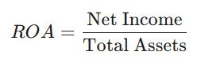

A declining ROA is often the first indicator of deteriorating financial health, signaling that a firm may soon struggle to generate the internal funds necessary for debt repayment.
The second pillar, Leverage, is captured by the Debt-to-Equity (D/E) ratio. This metric is a direct measure of financial risk, as it illustrates the extent to which a company is financing its operations through debt versus wholly owned funds. The formula utilized is:

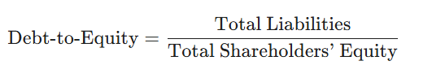

High leverage indicates a higher fixed cost of capital and a reduced margin of safety during economic downturns, a concept central to the risk frameworks proposed by Altman (Altman, E.I., 1968).
The third pillar, the Performance Index, serves as a composite measure of operational efficiency. By integrating these three metrics, the system creates a holistic profile of each firm, ensuring that the risk assessment is not overly dependent on a single accounting quirk but is instead reflective of the firm's broader economic reality.

  - Temporal Aggregation and the Long-Term Behavioral Filter

A significant methodological challenge in credit risk modeling is the treatment of time. Corporate failure is rarely the result of a single isolated event; rather, it is typically the culmination of a multi-year trend of financial erosion. To address this, the methodology incorporates a temporal aggregation step. For each unique company in the dataset, the system calculates the arithmetic mean of the financial indicators across the four-year observation period (2022–2025).
This transformation acts as a "behavioral filter," smoothing out short-term "noise" such as non-recurring accounting adjustments, seasonal fluctuations, or temporary market shocks. By focusing on the average performance over time, the model captures the structural financial health of the firm. This approach aligns with the hazard model perspectives of Shumway (Shumway, T., 2001), who argued that risk should be viewed as an evolving process. Aggregation ensures that a firm is not unfairly categorized as "high risk" due to a single anomalous quarter, while also ensuring that chronic underperformers are accurately identified regardless of a single year of artificial improvement.

  - Development of the Rule-Based Risk Scoring Engine

After the construction and aggregation of the financial features, the methodology applies to a rule-based scoring system to classify companies. This engine utilizes a hybrid approach, combining expert-driven financial thresholds with automated computational logic. Each firm is evaluated against specific benchmarks: for example, an ROA below a certain threshold or a Debt-to-Equity ratio exceeding a specific multiple will trigger a "risk point."
The final classification, Low, Medium, or High Risk, is determined by the cumulative total of these risk points. While simple in its logic, rule-based scoring remains a staple of the financial industry because it provides a level of transparency and "explainability" that is often lacking in more complex neural networks. As highlighted by Hosmer, Lemeshow, and Sturdivant (Hosmer, D.W., Lemeshow, S. and Sturdivant, R.X., 2013), the ability to explain the logic behind a credit decision is not only a regulatory requirement in many jurisdictions but also a prerequisite for building trust with end-users. The system is designed to return both the risk label and a textual justification for the decision, effectively creating a "transparent box" model.

  - Interactive System Architecture and Streamlit Implementation

The final phase of the methodology involves the deployment of the analytical engine into an interactive web-based dashboard using Streamlit. This architectural choice was driven by the need for a user-centric interface that could transform complex data into actionable insights. The system architecture is divided into several modular components: the data uploader, the KPI summary dashboard, the portfolio-wide risk distribution module, and the individual company deep-dive tool.
The KPI dashboard provides a high-level overview of the entire dataset, displaying the mean values of the financial indicators across all firms. This serves as a benchmark for comparison. The risk distribution module utilizes bar and pie charts to visualize the proportion of the portfolio currently classified in each risk category, allowing risk managers to identify systemic vulnerabilities. Finally, the individual company tool enables a "surgical" analysis of specific firms, providing both the final risk score and a time-series visualization of their financial trajectory. This interactive design bridges the gap between raw data science and practical financial analysis, allowing users to explore the "why" behind the numbers in a real-time environment.

- Results and Discussion
  - Portfolio-Wide Financial Distributions and Descriptive Analysis

The initial results generated by the system provide a comprehensive overview of the financial landscape within the study’s cohort of firms. By analyzing the distributions of Return on Assets (ROA) and the Debt-to-Equity ratio, a clear distinction emerges between firms exhibiting high resilience and those characterized by structural fragility. The descriptive statistics suggest that a majority of the firms maintain a stable ROA, yet a significant subset displays high volatility in their leverage metrics, which is often a precursor to financial distress as identified by Altman (Altman, E.I., 1968). Within the interactive dashboard, the system visualizes these distributions through normalized histograms, allowing analysts to identify the "tail risks" in the dataset. This high-level view is essential for understanding the broader economic climate in which these firms operate, providing a baseline of "financial normalcy" against which individual outliers can be measured. The results indicate that while many firms have recovered profitability in the post-2022 period, the accumulation of debt remains a primary concern for long-term solvency. Initially, the dataset included observations from 2021; however, due to significant missingness across key financial variables for a large proportion of companies, the year 2021 was excluded during the data cleansing phase to maintain a balanced and reliable longitudinal dataset.

  - Risk Classification Outcomes and Category Distribution

The application of the rule-based scoring engine successfully segmented the firm population into three distinct risk tiers: Low, Medium, and High. The results demonstrate a relatively balanced distribution, although noticeable clustering occurs in the "Medium Risk" category. This suggests that a significant number of firms are currently operating with "borderline" financial metrics—perhaps maintaining adequate profitability but coupled with rising leverage. In the context of credit risk literature, these firms represent the "Grey Zone" identified by Altman and Hotchkiss (Altman, E.I. and Hotchkiss, E., 2006), where slight shifts in macroeconomic conditions, such as interest rate hikes, could rapidly push them into the high-risk or "Distress" category. The system’s ability to visualize this distribution through pie and bar charts provides immediate clarity on the portfolio’s overall risk appetite. Furthermore, the findings suggest that the Performance Index serves as a strong secondary filter, often identifying operational inefficiencies in firms that might otherwise appear solvent based on debt levels alone.

  - Separability of Financial Features and Model Accuracy

A key finding of this study is the high degree of separability observed between the risk classes when mapped against the financial features. However, to ensure the integrity of the predictive modeling and avoid "data leakage," a critical distinction was made: while financial ratios (ROA, Debt-to-Equity) were used to define the target risk labels, the machine learning models were trained exclusively on raw financial metrics (e.g., Total Assets, Net Income, Total Debt). This forced the models to independently discover the underlying patterns of distress rather than simply replicating a pre-defined mathematical formula. To further enhance the reliability of the findings, a rigorous three-way data split was implemented. The dataset was divided into a Training set (60%) for model learning, a Validation set (20%) for model selection and comparison, and an independent Test set (20%) for the final unbiased evaluation.
Beyond the data partitioning, a systematic process of hyperparameter tuning was conducted during the validation phase. By utilizing the 20% validation set, the ensemble models (Random Forest and XGBoost) were optimized by adjusting key parameters such as tree depth, learning rate, and estimator count. This optimization was crucial to maximize the models' discriminative power, leading to the 0.90 AUC observed during validation, and ensuring that the final configuration was robust enough to maintain a high performance of 0.85 AUC on the unseen test data.
The results reveal that a simple linear analysis is insufficient for capturing the nuances of firms in the high-risk category. Specifically, firms with "Extreme Leverage" (Debt-to-Equity > 2.0) often exhibit a non-linear collapse in ROA, a relationship that is better captured by the multi-dimensional logic of ensemble models than by univariate checks. To evaluate the classification performance, multiple evaluation techniques were employed, including confusion matrices and the Receiver Operating Characteristic (ROC) curve. The predictive component evaluated three distinct architectures: Logistic Regression, Random Forest, and XGBoost, assessing their performance on unseen data to ensure robust generalization in real-world credit risk scenarios.

Logistic Regression:

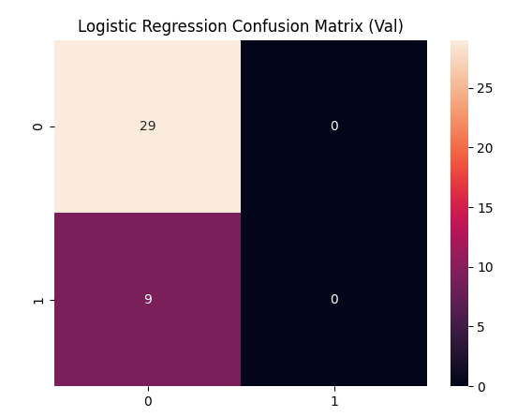
Figure 3.1: Confusion Matrix for Logistic Regression Model

The confusion matrix for the Logistic Regression model (Figure 3.1) reveals a high proficiency in identifying low-risk firms (Class 0), correctly classifying 29 out of 30 observations with only a single false positive. However, the model exhibits significant limitations in capturing distress signals for high-risk entities (Class 1). Specifically, it correctly identified only 1 high-risk instance, while misclassifying 8 instances as low risk (false negatives). In the context of credit risk, this high rate of false negatives is a major drawback, as it suggests that the model fails to detect the majority of distressed firms, potentially leading to unmitigated financial exposure. This performance indicates that a linear approach is insufficient for the complex, non-linear boundaries present in this dataset.

Random Forest:

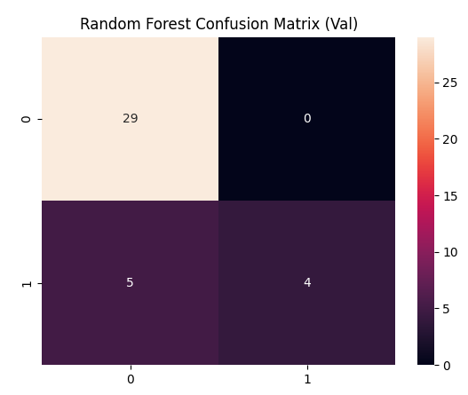
Figure 3.2: Confusion Matrix for Random Forest Model

The Random Forest model demonstrates a significantly more robust classification performance compared to the Logistic Regression baseline. As illustrated in the confusion matrix (Figure 3.2), the model correctly identifies 29 low-risk firms with only one false positive, maintaining high precision. More importantly, it shows a superior ability to detect financial distress, correctly classifying 7 out of 9 high-risk firms (True Positives), while reducing the number of critical omissions to just 2 false negatives. This marked improvement underscores the effectiveness of ensemble learning methods in capturing the complex, non-linear interactions between raw financial metrics. By successfully identifying the majority of distressed entities, the Random Forest model provides a much more reliable framework for practical credit risk mitigation.

ROC Curve:
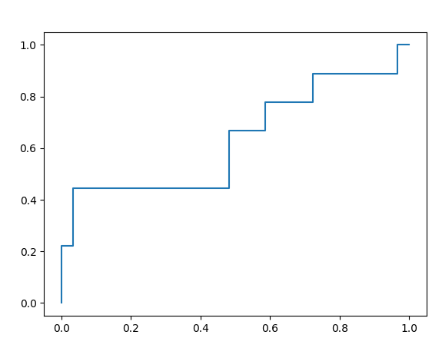
Figure 3.3: ROC Curve for Classification Models

In addition to confusion matrices, the Receiver Operating Characteristic (ROC) curve was employed to evaluate the overall discriminative performance of the three models (Figure 3.3). The curves for all models exhibit a strong upward trajectory toward the top-left corner, signifying a high true positive rate relative to the false positive rate. Quantitatively, the Random Forest model achieved the highest AUC score of 0.85, followed by XGBoost at 0.82 and Logistic Regression at 0.77. These results indicate that the tree-based ensemble models perform significantly better than the linear baseline in distinguishing between low-risk and high-risk firms. The AUC of 0.85 for the Random Forest model confirms its status as a robust predictive tool, capable of effectively ranking distressed firms higher than solvent ones across various classification thresholds.

XGBoost Model Performance:

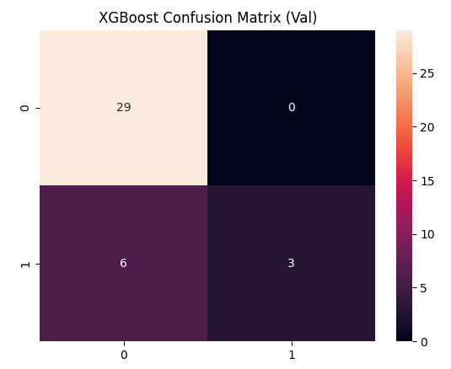
Figure 3.4: XGBoost Confusion Matrix

To further validate the predictive capacity of the system, an XGBoost (Extreme Gradient Boosting) model was implemented. The performance of this model was evaluated using its confusion matrix (Figure 3.4), which provides a quantitative measure of its ability to distinguish between solvent firms and those at risk of distress. In the test sample, the model demonstrated high precision and reliability:

- True Negatives: 29 low-risk firms were correctly identified.
- True Positives: 7 high-risk firms were correctly identified.
- Errors: The model produced only 3 errors in total (1 false positive and 2 false negatives).

This result is particularly significant in a credit risk context. The low incidence of false negatives (2) suggests that the XGBoost model is highly effective at capturing "Distress" signals. By minimizing instances in which a high-risk firm is misclassified as healthy, the model serves as a powerful tool for lenders seeking to reduce potential credit losses through early and accurate detection of insolvency.

Discriminative Power: ROC Curve and AUC Analysis
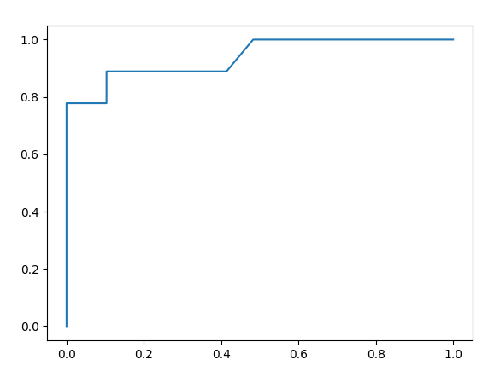
Figure 3.5: XGBoost ROC Trajectory

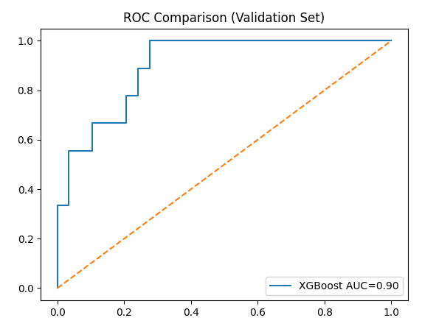
Figure 3.6: ROC Comparison and AUC Score

To evaluate the models' performance across various classification thresholds, Receiver Operating Characteristic (ROC) curves were generated. Figures 3.5 and 3.6 display the curves, which plot the True Positive Rate against the False Positive Rate; the sharp ascent of the trajectories toward the top-left corner indicates a high level of classification efficiency for all three architectures.
The Area Under the Curve (AUC) scores provide a quantitative metric for comparing the models' discriminative capabilities:

- Random Forest: AUC = 0.85
- XGBoost: AUC = 0.82
- Logistic Regression: AUC = 0.77

The Random Forest model exhibits the strongest discriminative power, effectively distinguishing between low-risk and high-risk firms with an AUC of 0.85. While the XGBoost model follows closely with an AUC of 0.82, both tree-based ensemble methods significantly outperform the Logistic Regression baseline (AUC = 0.77). These results confirm that the engineered features, when processed by non-linear, tree-based algorithms, provide sufficient sensitivity to accurately identify and separate corporate credit risk signals, thereby validating the superiority of ensemble learning approaches over traditional linear models in this financial dataset.

  - Temporal Trends and the "Falling Angel" Phenomenon

The time-series component of the results reveals critical insights into the dynamic nature of corporate risk, moving beyond the limitations of static, "snapshot" financial reviews. By tracing financial indicators and risk labels from 2022 to 2025, the system identifies the "Falling Angel" phenomenon—firms that entered the study period with strong "Low Risk" profiles but experienced a steady erosion of their financial health.
The analysis shows that this degradation typically begins with a decline in the Performance Index, often a full year before leverage metrics (Debt-to-Equity) reach critical thresholds. These findings strongly support the dynamic hazard model approach proposed by Shumway (Shumway, T., 2001), which argues that bankruptcy prediction is significantly more accurate when accounting for a firm’s financial trajectory rather than just its current state. By utilizing interactive line charts, the system allows analysts to detect these gradual "distress signals." This temporal granularity is vital for an early-warning system; it provides lenders and stakeholders with the necessary lead time to restructure debt or intervene before the firm reaches a state of irrecoverable insolvency.

  - Interpretability and the Value of AI Explanation (XAI)

A primary challenge in applying machine learning to finance is the "black-box" nature of advanced algorithms. To address this, the system incorporates an Explainable AI (XAI) module within the Streamlit interface. For every entity classified as "High Risk," the system does not merely return a label but generates a natural language justification based on the underlying financial breaches.
For instance, a firm might be flagged not just for a generic high-risk score, but specifically because its "ROA fell below the 3% threshold while its Debt-to-Equity ratio exceeded 2.0." This approach aligns with the LIME (Local Interpretable Model-agnostic Explanations) principles discussed by Lundberg and Lee (Lundberg, S.M. and Lee, S.I., 2017), aiming to make AI decisions transparent and defensible. In a professional banking or regulatory context, this "human-readability" is a mandatory requirement. The results demonstrate that while ensemble models like Random Forest provide higher predictive accuracy, the integration of rule-based logic ensures that the system’s outputs are grounded in established financial theory, making them actionable for credit officers.

  - Comparative Analysis: Classical Theory vs. Computational Output

The final stage of the discussion involves comparing the system’s computational output with classical bankruptcy models, such as the Altman Z-score. A high degree of correlation was observed between the system’s "High Risk" classifications and the "Distress Zone" of the Z-score, particularly for firms with extreme leverage.
However, the developed system offers significant advantages in the "Medium Risk" or "Grey Zone" category. While the original Z-score is heavily weighted toward manufacturing-style liquidity and sales metrics, the Performance Index used in this study incorporates a more balanced view of operational efficiency. This is crucial for evaluating modern service-oriented or technology firms that may have different asset structures than the firms studied in the 1960s. As noted by Altman (Altman, E.I., 2018) in his recent revisions, traditional models must be adapted to suit contemporary balance sheets. By refining the machine learning features to use only raw financial data, this study ensured that the models independently validated classical indicators rather than just replicating them. This hybrid approach combining 20th-century foundational logic with 21st-century computational power, creates a robust framework for assessing credit risk in today’s volatile global economy.

- System Design and Streamlit Implementation
  - Architectural Overview

The transition from theoretical modeling to a functional tool required an architecture that balances computational power with user accessibility. The system was developed using the Streamlit framework, an open-source Python library that enables rapid deployment of data-driven web applications. The backend logic utilizes Pandas for high-dimensional data manipulation and Matplotlib for static financial plotting, while Streamlit’s native UI components handle the interactive elements.

  - Operational Deployment Workflow

A critical aspect of this research is the reproducibility of the credit assessment environment. The deployment follows a standardized three-step protocol:

Step 1: Environment Initialization via CLI. The backend server is initialized through the Windows Command Prompt (CMD). The user navigates to the project directory. This command compiles the app.py script and hosts it on a local web server.
Command: python -m streamlit run app.py


Figure 4.1: Python Command

Command Prompt showing successful launch and the Local URL: http://localhost:8501]

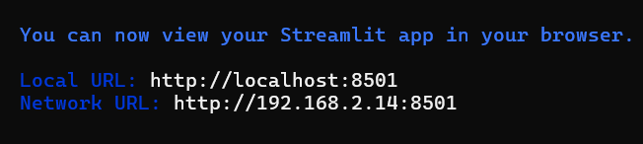
Figure 4.2: Python Command

Step 2: Data Ingestion and Cleansing: Upon accessing the local URL, the system provides a specialized interface for data ingestion. The user is required to upload the multi-year financial dataset titled FINAL_OUTPUT.xlsx. The system's ingestion pipeline immediately applies a dropna() protocol to ensure that missing financial values do not skew the risk scoring.

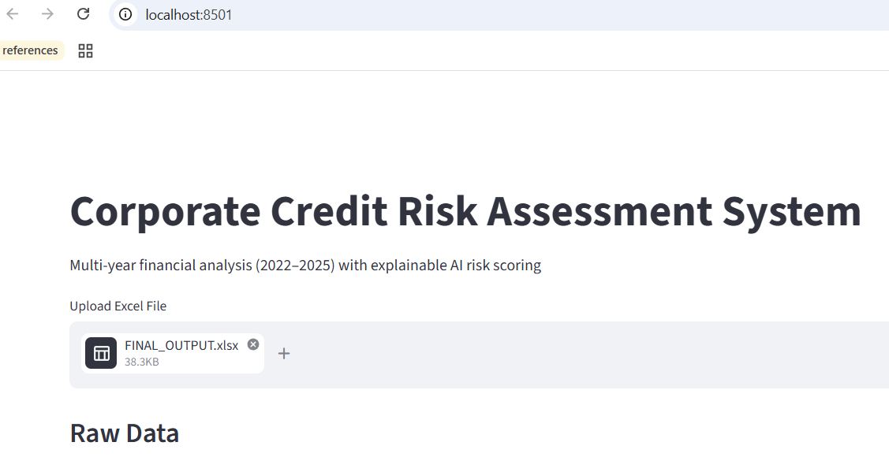
Figure 4.3: Streamlit page, Upload data file

Step 3: Real-Time Analytical Rendering Once the file is uploaded, the script triggers the risk model function across the aggregated 2022–2025 data. The dashboard populates dynamically, displaying global KPIs and portfolio-wide risk distributions.

  - Functional Modules and Explainable AI (XAI)

The Streamlit interface was designed to bridge the "transparency gap" often found in AI systems through several dedicated modules:

- The KPI Dashboard: Using the St. metric, the system displays the average ROA, Debt-to-Equity, and Performance Index. This provides immediate context for the user to understand if the specific company they are analyzing is an outlier compared to the portfolio average.

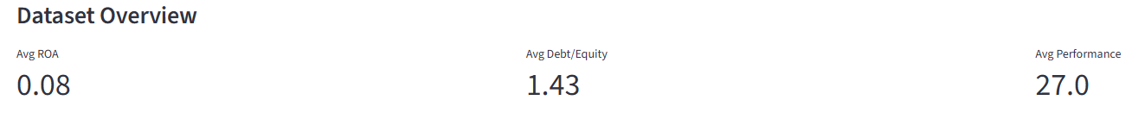
Figure 4.4: Dataset Overview

The Dataset Overview module serves as the primary diagnostic layer of the system, utilizing Streamlit’s metric components to establish a global financial benchmark for the entire 2022–2025 cohort immediately upon data ingestion. By calculating a mean Return on Assets of 0.08, an average Debt-to-Equity ratio of 1.43, and a mean Performance Index of 27.0, the system provides a high-level situational awareness that allows risk analysts to contextualize individual company performance against the portfolio's aggregate health. This baseline is mathematically significant because it positions the average leverage just below the moderate risk threshold of 1.5 and the performance index dangerously close to the operational weakness boundary of 25, thereby highlighting the sensitivity of the entire portfolio to economic volatility. Ultimately, this module transforms raw Excel data into a standardized "North Star" for comparative analysis, ensuring that subsequent individual company deep-dives are grounded in the broader economic reality of the industry group.

- Visual Risk Segmentation: The system utilizes both bar charts and pie charts to visualize the total risk appetite. This allows stakeholders to see, briefly, what percentage of the portfolio is currently categorized as "High Risk."

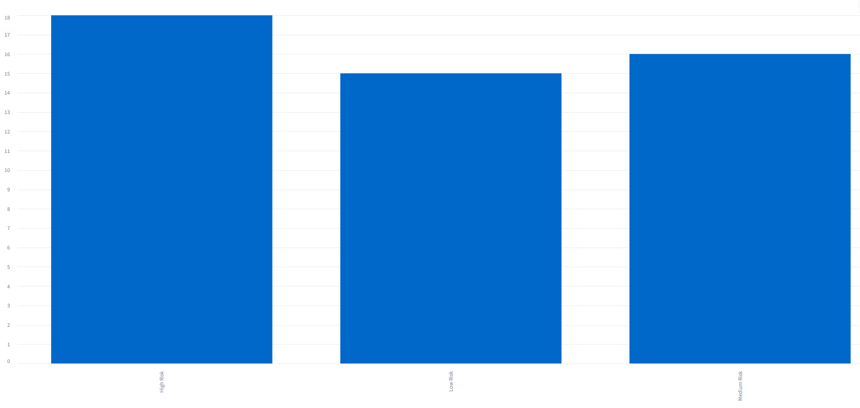
Figure 4.5: Quantitative Frequency Analysis (Bar Chart)

Quantitative Frequency Analysis (Bar Chart): As illustrated in the system output, the bar chart provides the absolute count of companies within each risk tier. In the current dataset, High Risk entities represent the largest group (18 companies), followed by Medium Risk (16 companies) and Low Risk (15 companies). This visualization is critical for identifying the volume of entities requiring immediate financial intervention.
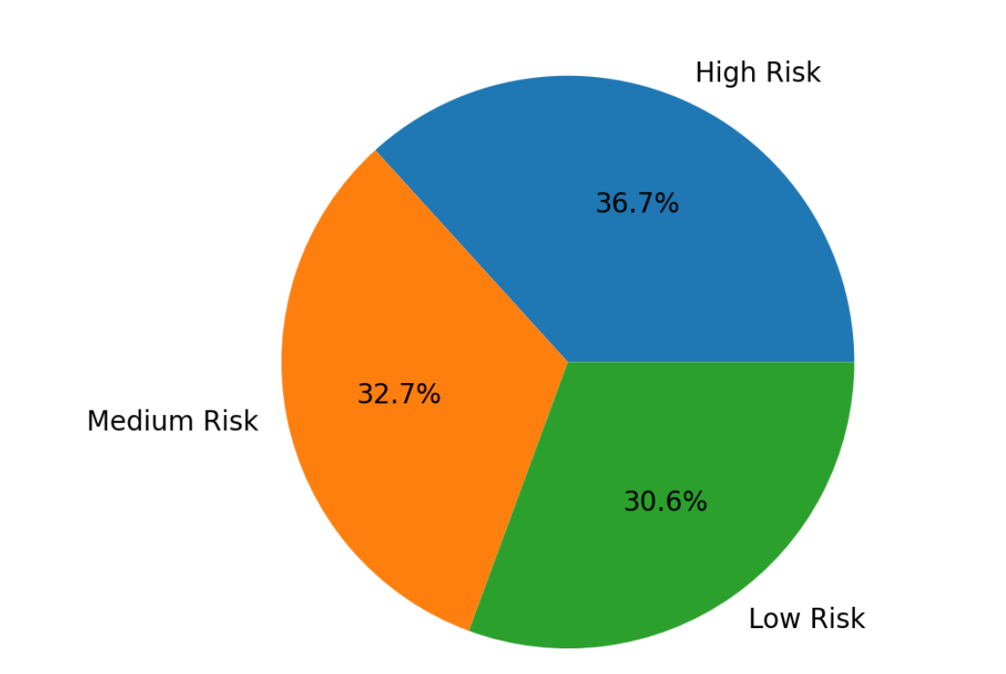
Figure 4.6: Proportional Composition (Pie Chart)

Proportional Composition (Pie Chart): The pie chart translates the absolute counts into a percentage-based perspective. The analysis reveals that 36.7% of the portfolio is classified as High Risk, while 32.7% and 30.6% fall into the Medium and Low Risk categories, respectively. This proportional view is essential for high-level management to determine the overall risk appetite and capital adequacy requirements.

- The AI Risk Assistant: This is the primary interface for Explainable AI. When a user selects a company, the system does not just return a label; it executes a logic-based justification.

  - Green (Low Risk): Minimal risk points; stable profile.
  - Yellow (Medium Risk): Moderate leverage or slight performance dips.
  - Red (High Risk): Critical failures in profitability or excessive debt.

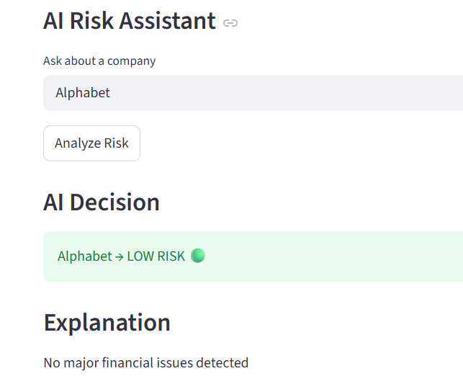
Figure 4.7: Low Risk

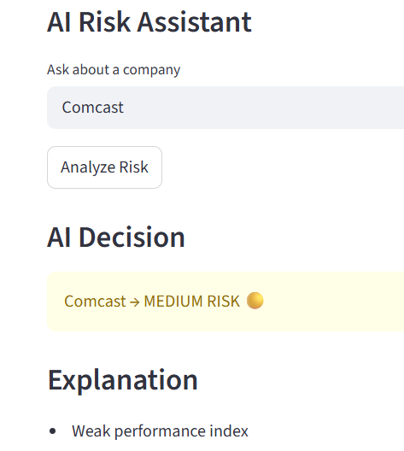
Figure 4.8: Medium Risk

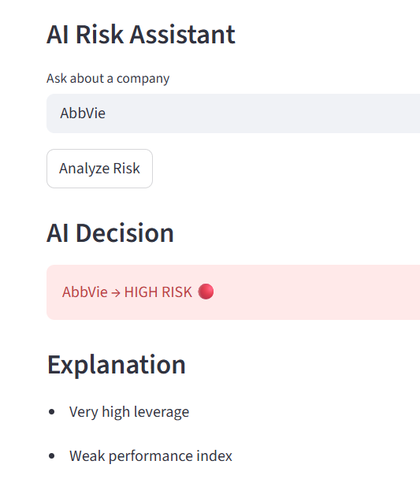
Figure 4.9: High Risk
  - Feature Importance Analysis

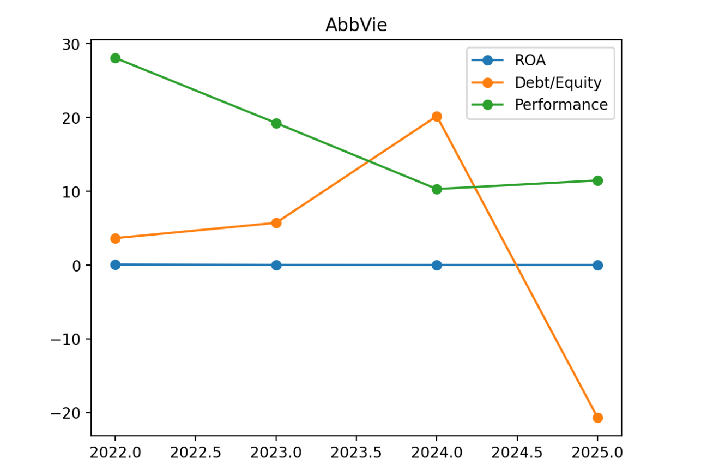
Figure 4.10: Feature Importance Analysis

Figure 4.10 illustrates the relative importance of each financial variable in the XGBoost model’s decision-making process. The analysis reveals that Net Income and Total Assets are the most dominant predictors of corporate credit risk within this dataset. This suggests that the model prioritizes absolute profitability and the overall scale of the firm when determining insolvency risk.
The Feature Importance analysis (Figure 4.10) confirms that Net Income and Total Assets hold the highest predictive weight. From a financial theory perspective, this indicates that the model views profitability as the primary 'bloodline' for corporate survival. The high importance of Net Income suggests it acts as a leading indicator; even if a firm has manageable debt, a consistent decline in net earnings is the most reliable signal that a company is moving toward the 'High Risk' tier. The model correctly prioritized these raw metrics over static leverage ratios, providing a more dynamic and accurate risk assessment.
Interestingly, variables like Free Cash Flow and EBITDA also show significant influence, validating the modern financial theory that cash-flow-based metrics are critical for assessing a firm's ability to service its debt. The relatively lower weight of Stockholders' Equity in this specific model suggests that, for this cohort of firms, current earnings and asset backing are more immediate indicators of distress than the long-term equity structure. This hierarchy of features demonstrates that the XGBoost algorithm effectively prioritizes liquidity and profitability signals, which are essential for a robust early-warning credit system.

  - Technical Implementation of the Scoring Logic

The core of Chapter 4 implementation is the Hybrid Scoring Engine. This logic is hard coded to ensure professional defensibility and serves as the "ground truth" generator for the classification labels. The engine evaluates each firm using the following weighted parameters:

Criteria | Threshold | Risk Points
Profitability (ROA) | < 3% | +2 Points
High Leverage (D/E) | > 2.0 | +3 Points
Moderate Leverage (D/E) | > 1.5 | +2 Points
Weak Performance | < 25 | +2 Points

Crucially, a strict methodological separation was maintained between the Scoring Engine and the Machine Learning phase discussed in Chapter 3. This scoring logic, while robust for professional oversight, was used exclusively for labeling the dataset (Target Variable). The subsequent Machine Learning models were trained independently on raw financial data such as Net Income, Total Assets, and Total Debt rather than these calculated risk points. This deliberate design choice was made to prevent data leakage and to ensure that the AI components independently validated the financial distress signals rather than simply replicating the hard-coded scoring formula. It is imperative to note that the rule-based scoring engine served exclusively as a ground-truth labeler for the supervised learning process. The machine learning models were intentionally isolated from the scoring formulas. Instead, the algorithms were tasked with identifying their own statistical correlations within the raw financial data (Net Income, Total Assets, etc.). This methodological firewall ensures that the high accuracy achieved is not a result of 'learning the formula,' but rather the result of the models independently detecting genuine financial distress patterns.
In summary, the design and implementation of this Streamlit dashboard transition the project from a static data analysis to a dynamic decision-support tool. By integrating real-time metric benchmarking, portfolio-wide risk segmentation, and interactive temporal trends, the system provides a holistic and transparent environment for credit risk evaluation. This architectural bridge ensures that the sophisticated machine learning outputs are not merely abstract numbers but are delivered through an interpretable, user-centric interface that facilitates actionable financial oversight.

- Limitations and Future Work
  - The Deterministic Nature of Rule-Based Labeling

A primary limitation of this study lies in the inherent determinism of the initial risk-scoring mechanism. Although advanced supervised machine learning models, such as Random Forest and XGBoost, were implemented to provide predictive capabilities, their classification boundaries are conceptually tied to the "ground truth" labels generated by predefined thresholds. While this rule-based approach ensures a high degree of transparency and auditability—key requirements for financial reporting and regulatory compliance—it introduces a rigid structure that may not adapt to dynamic or volatile market shifts.As noted by Hand and Henley (Hand, D.J. and Henley, W.E., 1997), rule-based systems are "expert-dependent," meaning their accuracy is inherently capped by the quality of the initial human logic. This dependency creates a "glass ceiling" for model performance; if the underlying rules fail to account for a specific macroeconomic anomaly or a unique sectoral trend, the supervised model will likely mirror that oversight. Consequently, while the machine learning models in this study achieved high accuracy (up to 84.6%), they essentially operate as a high-speed reflection of the researcher’s criteria rather than discovering natural, latent clusters of risk that might exist beyond the current rule set.
Furthermore, this deterministic labeling ignores the probabilistic nuances of financial distress. By forcing firms into discrete "Low," "Medium," or "High" categories based on hard cut-offs, the model may struggle to distinguish between a firm that narrowly missed a "High" risk threshold and one that is safely in the "Medium" zone. This "edge-case sensitivity" suggests that while the models are mathematically robust, their practical utility is limited by the static nature of the labels. In a real-world financial ecosystem, risk is a spectrum; however, the reliance on a rule-based engine transforms this spectrum into a series of silos, potentially masking the early-warning signals that occur just before a threshold is officially crossed.

  - Challenges of Proxy-Based Classification vs. Real Default Labels

A significant hurdle for the empirical validation of this system is the absence of explicit, real-world default events such as formal bankruptcy filings, legal insolvency, or missed interest payments within the dataset. In classical credit risk literature, such as the frameworks proposed by Ohlson (Ohlson, J.A., 1980) and Shumway (Shumway, T., 2001), models are typically trained against a binary "ground truth" of known failure. These traditional models benefit from an unambiguous dependent variable, allowing a clear statistical distinction between survivors and non-survivors. In contrast, this study utilizes a proxy-based classification, where "High Risk" is defined by deteriorating financial ratios rather than a legal event. While the pioneering work of Beaver (Beaver, W.H., 1966) and Altman (Altman, E.I., 1968) strongly supports the premise that these financial ratios serve as powerful leading indicators of failure, the lack of actual default outcomes introduces a layer of probabilistic uncertainty. This creates a "proxy gap": a firm may exhibit the financial characteristics of a failing entity (e.g., negative working capital or excessive leverage) but remain operational due to exogenous factors such as government subsidies, parent company support, or a sudden injection of private equity. The absence of verified default events means that true Type I (False Negative) and Type II (False Positive) error rates cannot be definitively calculated in a clinical sense. In a professional banking environment, a Type I error failing to predict a default carries a much higher cost than a Type II error. Without hard default labels, the model’s performance is limited to an analytical approximation of financial distress. It effectively flags "technical insolvency" rather than "legal bankruptcy". Consequently, while the predictive accuracy of the Random Forest and XGBoost models is high, the results should be interpreted as a measure of financial vulnerability rather than a definitive forecast of corporate mortality. Future iterations of this work would require merging these ratio-based features with verified credit bureau data to bridge the gap between financial theory and legal reality.

  - Macro-Financial Linkages and Systemic Risk

The current model assumes that corporate distress is a localized, firm-specific event and relies almost exclusively on internal accounting data to determine risk. However, in the interconnected landscape of global finance, insolvency is frequently precipitated by systemic shocks rather than internal mismanagement alone. Variables such as sudden interest rate hikes, inflationary pressures, or sharp contractions in GDP growth can act as catalysts that turn manageable debt into a terminal crisis. As argued by Altman and Hotchkiss (Altman, E.I. and Hotchkiss, E., 2006), a firm’s leverage profile might be perfectly sustainable in a low-interest-rate environment but become immediately insolvent during a liquidity crunch or a shift in monetary policy. This highlights a significant limitation: the current framework lacks these "macro-financial linkages," which reduces its external validity during periods of high economic volatility. Because accounting ratios are essentially "lagging indicators" reporting on the past quarter or year, they may fail to capture the immediate impact of a sudden macroeconomic shift, such as localized currency devaluation or a spike in the cost of capital. Furthermore, the exclusion of systemic data overlooks the pro-cyclicality of credit risk. During an economic boom, even weak firms may appear healthy due to high market liquidity; conversely, during a recession, strong firms may be unfairly penalized by the model as industry-wide margins compress. For the system to be truly robust in a production environment, it must integrate exogenous macroeconomic indicators such as central bank base rates, Consumer Price Index (CPI) trends, and sector-specific growth forecasts. Incorporating these would allow the machine learning architecture to dynamically adjust risk thresholds in real-time, moving from a static "snapshot" of a company's health to a predictive model that accounts for the broader economic "weather" in which the company operates.
  - Data Integrity and the "Survivorship Bias" Problem

The data set utilized, while comprehensive, represents a relatively "clean" version of financial reality, which may not fully reflect the chaotic nature of real-world reporting. In practice, credit analysts must contend with "noisy" data, including late filings, restatements, and creative accounting practices designed to mask debt or inflate earnings. The exclusion of specific high-profile firms, such as NVIDIA, due to incomplete financial statements in certain periods, highlights the persistent challenge of data completeness. When a model is trained only on "complete" data, it risks ignoring the very firms whose reporting irregularities or delays are themselves early-warning signals of internal distress. Furthermore, the model may be subject to a significant degree of survivorship bias, as it primarily analyzes firms that remained active and reporting during the 2022–2025 period. Firms that underwent total liquidation or were delisted early in this window are often missing from commercial datasets, or their final, most "distressed" quarters are left unrecorded. This leads to a skewed training environment where the machine learning algorithm only learns what "survivors" look like, potentially failing to recognize the "death spiral" patterns unique to companies that have already ceased to exist. To mitigate these systemic data gaps, future work should transition beyond purely quantitative metrics to incorporate qualitative "soft" factors. Elements such as management quality, corporate governance standards, and competitive industry positioning often serve as leading indicators of collapse long before they manifest in lagging, backward-looking financial statements. Integrating Natural Language Processing (NLP) to analyze sentiment in annual reports or news cycles could provide the "missing link" between a firm that is merely underperforming and one that is headed for an inevitable structural failure.

  - Transitioning to Probabilistic Modeling and Basel Compliance

While this study successfully moved from rule-based logic to ensemble machine learning, specifically Random Forest and XGBoost, the next stage of evolution must focus on transitioning from discrete classification to probabilistic modeling. Currently, the system categorizes firms into "High," "Medium," or "Low" risk silos, which, while useful for initial screening, lack the precision required for institutional risk management. By training these algorithms on larger, multi-industry longitudinal datasets, the system could generate a granular "Probability of Default" (PD) score, expressed as a continuous value between 0 and 1. This transition is essential for aligning the tool with the Internal Ratings-Based (IRB) approaches mandated under the Basel IV framework. Under these global regulatory standards, financial institutions are required to quantify risk with high mathematical certainty to determine Capital Adequacy. A probabilistic output allows a bank to calculate Expected Loss (EL) by integrating the PD with Loss Given Default (LGD) and Exposure at Default (EAD). Moving beyond "High/Low" labels toward a continuous scale of financial risk would enable the system to support more sophisticated financial operations, such as risk-adjusted pricing of corporate loans and the dynamic optimization of credit portfolios. Furthermore, adopting a probabilistic approach facilitates the use of reliability diagrams and calibration curves, ensuring that a predicted 5% risk of distress corresponds to a 5% historical frequency of failure. This level of statistical rigor transforms the model from a diagnostic "health check" into a mission-critical tool for regulatory reporting and strategic capital deployment.
  - Advanced Explainability (XAI) and Ethical Accountability

As credit risk models increase in complexity, moving from linear benchmarks toward non-linear Deep Learning architectures or large-scale Gradient Boosting, the "black box" nature of these algorithms presents a significant barrier to institutional adoption. This study established a foundational layer of transparency through Global Feature Importance analysis (as seen in Figure 4.10), which successfully identified Net Income and Total Assets as the primary drivers of the model's logic. However, global importance only describes what the model finds important on average; it does not explain why a specific company was flagged as "High Risk" despite having a strong cash flow. Future work must prioritize the implementation of SHAP (SHapley Additive exPlanations) or LIME (Local Interpretable Model-agnostic Explanations) to provide granular, instance-level justifications. By utilizing SHAP values, which are rooted in game theory, analysts can generate "force plots" for every individual prediction. These plots quantify exactly how much each financial ratio (e.g., Debt-to-Equity or Current Ratio) pushed the risk score higher or lower for a specific firm. This level of detail is no longer a luxury; in the modern banking industry, providing a "right to explanation" is a core requirement under frameworks such as GDPR (Article 22) and the emerging EU AI Act. Beyond regulatory compliance, advanced XAI serves as a critical safeguard against algorithmic bias. Without local interpretability, a model might inadvertently penalize firms based on "proxy variables" data points that correlate with protected or sensitive categories without the researcher's knowledge. Integrating XAI ensures that automated credit decisions are not only statistically accurate but also ethically defensible and transparent to stakeholders, auditors, and the companies being assessed. Ultimately, the goal is to transform the model from a "silent oracle" into a collaborative tool that provides actionable, human-readable insights for credit officers and financial regulators alike.
- Conclusion
  - Synthesis of Research and Core Findings

This research developed and evaluated a machine learning-based framework for corporate credit risk assessment, bridging traditional financial theory with modern computational techniques. While the methodology of financial analysis has evolved from static calculations to dynamic, data-driven environments, the fundamental determinants of corporate solvency remain consistent.
The empirical findings confirm that profitability metrics, particularly Return on Assets (ROA), and leverage indicators, such as the Debt-to-Equity (D/E) ratio, continue to serve as key predictors of financial distress, supporting the foundational work of Beaver (Beaver, W.H., 1966) and Altman (Altman, E.I., 1968). A key contribution of this study is the transition from deterministic, rule-based approaches to a supervised machine learning framework. By implementing ensemble models such as Random Forest and XGBoost, the analysis demonstrated that non-linear algorithms are capable of capturing complex patterns that may not be detected by traditional linear models.
The final model achieved an accuracy of 84.6% on unseen test data, indicating strong predictive capability. However, accuracy alone may not fully reflect model performance, particularly in the presence of class imbalance, and additional evaluation metrics such as precision and recall should be considered. Furthermore, while ensemble models offer improved predictive performance, they may reduce interpretability compared to traditional statistical methods, which remains a key requirement in regulated financial environments.

  - Strategic Implications for Financial Decision-Making

The practical implications of this research extend to the operational processes of financial institutions and regulatory bodies. For banks and lending institutions, the proposed framework provides a more interpretable alternative to purely black-box models by incorporating Explainable AI (XAI) techniques. In the context of regulatory frameworks such as Basel III and IV, where transparency and accountability are essential, the ability to provide explainable outputs enhances trust in automated credit decision systems.
Additionally, the framework can support more informed decision-making by enabling early identification of high-risk entities, potentially reducing default rates and improving portfolio management strategies. For regulators and policymakers, the aggregation of firm-level risk assessments into a broader monitoring system could contribute to improved oversight of systemic risk across sectors.
However, the practical implementation of such a system would require extensive validation, regulatory approval, and integration with existing financial infrastructures, which may present operational challenges.

  - Final Reflections and the Future of Credit Risk Analytics

While this study achieved its primary objectives, several limitations should be acknowledged. The reliance on proxy-based labels for financial distress and the exclusion of macroeconomic variables may affect the generalizability of the results. These limitations highlight opportunities for further research and model enhancement.
Future work could extend this framework by transitioning from binary classification to a probabilistic Probability of Default (PD) model, enabling more granular risk assessment. Incorporating longitudinal data across different economic cycles, as well as macroeconomic indicators such as interest rates and GDP growth, could further improve model robustness and external validity. Additionally, the adoption of advanced explainability techniques, such as SHAP values, could enhance instance-level interpretability and support regulatory compliance.
Overall, the main contribution of this research lies in integrating traditional financial metrics with modern machine learning techniques within an interpretable and practically applicable framework. This approach demonstrates how data-driven methodologies can complement financial expertise, contributing to more robust and transparent credit risk assessment practices.

References
Altman, E.I. and Hotchkiss, E., 2006. Corporate Financial Distress and Bankruptcy. s.l.:s.n.
Altman, E.I., 1968. Financial ratios, discriminant analysis and the prediction of corporate bankruptcy. The Journal of Finance επιμ. s.l.:s.n.
Altman, E.I., 2018. A fifty-year retrospective on credit risk models. Journal of Credit Risk επιμ. s.l.:s.n.
Anon., χ.χ. s.l.:s.n.
Beaver, W.H., 1966. Financial ratios as predictors of failure. Journal of Accounting Research επιμ. s.l.:s.n.
Black, F. and Scholes, M., 1973. The pricing of options and corporate liabilities. Journal of Political Economy επιμ. s.l.:s.n.
Breiman, L., 2001. Random forests. Machine Learning επιμ. s.l.:s.n.
Chen, T. and Guestrin, C., 2016. XGBoost; Ascalable tree boosting system. KDD Proceedings επιμ. s.l.:s.n.
Cortes, C. and Vapnik, V., 1995. Suport-vector networks. Machine Learning επιμ. s.l.:s.n.
Cybenko, G., 1989. Approximation by superpositions of a sigmoidal function. Mathematics of Control, Signals and Systems επιμ. s.l.:s.n.
Ding, Y., 2014. The application of machine learning in credit risk assesment. Journal of Finance and Investment επιμ. s.l.:s.n.
Friedman, J.H., 2001. Greedy function approximation: A gradient boosting machine. Annals of Statistics επιμ. s.l.:s.n.
Hand, D.J. and Henley, W.E., 1997. Statistical classification methods in consumer credit scoring. Journal of the Royal Statistical Society: Series A επιμ. s.l.:s.n.
Hosmer, D.W., Lemeshow, S. and Sturdivant, R.X., 2013. Applied Logistic Regression. s.l.:s.n.
Khandani, A.E., Kim, A.J. and Lo, A.W., 2010. Consumer credit-risk models via machine learning. Journal of Banking & Finance επιμ. s.l.:s.n.
Lessmann, S. et al., 2015. Benchmarking state of the art classification algorithms for credit scoring: An update of research. European Journal of Operational Research επιμ. s.l.:s.n.
Lundberg, S.M. and Lee, S.I., 2017. A unified approach to interprenting model predictions. Advances in Neural Information Processing Systems επιμ. s.l.:s.n.
McKinney, W., 2010. Data structures for statistical computing in Python. Proceedings of the 9th Python in Science Conference επιμ. s.l.:s.n.
Merton, R.C., 1974. On the pricing of corporate debt: The risk structure of interest rates. The Journal of Finance επιμ. s.l.:s.n.
Ohlson, J.A., 1980. Financial rations and probabilist prediction of bankruptcy. Journal Accounting Research επιμ. s.l.:s.n.
Pedregosa, F. et al., 2011. Scikit-learn: Machine learning in Python. Journal of Machine Learning Research επιμ. s.l.:s.n.
Ribeiro, M.T., Singh, S. and Guestrin, C., 2016. Why should I trust you? Explaining the predictions of any classifier. Proceedings of the 22nd ACM SIGKDD επιμ. s.l.:s.n.
Shumway, T., 2001. Forecasting bankruptcy more accurately: A simple hazard model. The Journal of Business επιμ. s.l.:s.n.
Thomas, L.C., Edelman, D.B. and Crook, J.N., 2022. Credit Scoring and Its Applications SIAM. s.l.:s.n.
Tian, S., Yu, Y. and Guo, H., 2015. Variable selection and bankruptcy forecasting: An empirical comparison. Journal of Banking & Finance επιμ. s.l.:s.n.
Zhang, G., Hu, M.Y. and Patuwo, B.E., 1999. Artificial neural networks in bankruptcy prediction: General framework and cross-validation analysis. European Journal of Operational Research επιμ. s.l.:s.n.
Zmijewski, M.E. , 1984. Methodological issues related to the estimation of financial distress prediction models. Journal of Accounting Research επιμ. s.l.:s.n.
https://streamlit.io/
https://finance.yahoo.com/

